## Case Study: Ames Iowa Housing Prices

#### Data Description:

See appendix A for a detailed description of the dataset

Data Questions:

Is the client only concerned with residential sales? Should model scope be limited?

Reclassify MSSubClass as factor

#### Missing Data:

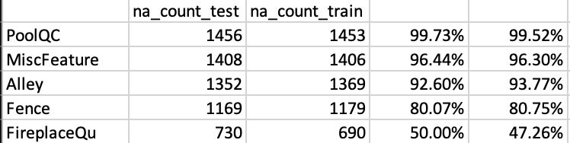

Missing data seems to be an issue for a few of the features – namely PoolQC, MiscFeature?

#### Train/Test Balance:

Data seems well balanced by neighborhood with respect to the explanatory variables in QOI #1 (GrLivArea and Neighborhood)

TODO: Shrink

|  |  |  |  |  |  |  |  |
| --- | --- | --- | --- | --- | --- | --- | --- |
|  |  | **Count** | | | **Average Square Footage** | | |
| **Neighborhood** | **Average Sale Price** | **Train** | **Test** | **Balance** | **Train** | **Test** | **Balance** |
| BrkSide | 124,834 | 58 | 50 | 86% | 1,203 | 1,272 | 106% |
| NAmes | 145,847 | 225 | 218 | 97% | 1,310 | 1,273 | 97% |
| Edwards | 128,220 | 100 | 94 | 94% | 1,340 | 1,335 | 100% |

Ultimately, training the model will be done on a 5(?) fold cross validation scheme and then the model will be run against a test set.

#### Problem Statement:

Century 21 seeks to answer two questions related to housing prices in Iowa:

* QOI 1: Is there a relationship between square footage and sale price?
* QOI 2: Is this relationship dependent on neighborhood?

The data set we will be using will only consider a subset of the available features we could use to build a better model. Since the analysis at hand only seeks to answer questions related to house size and location – we will limit the analysis to only those variables and leave the investigation of further explanatory variable dependencies for future studies.

#### Modeling:

#### QOI: Is there a relationship between square footage (GrLivArea) and sale price (SalePrice)

To answer this we will first run a basic linear regression of the form:

SalePrice = 0 + 1 GrLivArea

#### Checking Assumptions

#### Normality:

TODO: add leverage stats

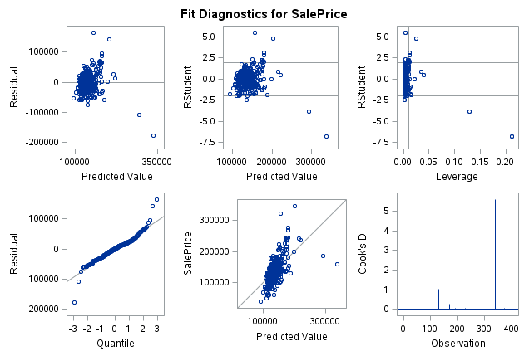

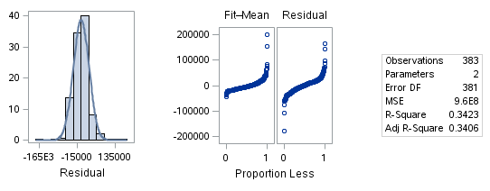

Scatter, Q-Q plot and histogram of residuals are all relatively normal. There appear to be some influential observations for the following:

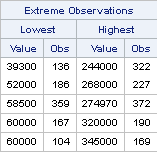

Observation 322 appears problematic and is a candidate for being dropped (cook’s D >5)

Let’s run the analysis with all of the extreme observations removed and see if there is a significant difference in the predictive power of the model:

W/OUTLIERS: W/O OUTLIERS:

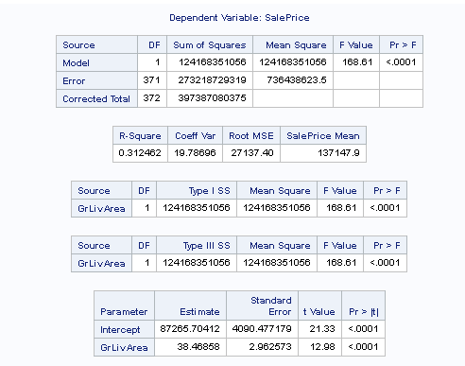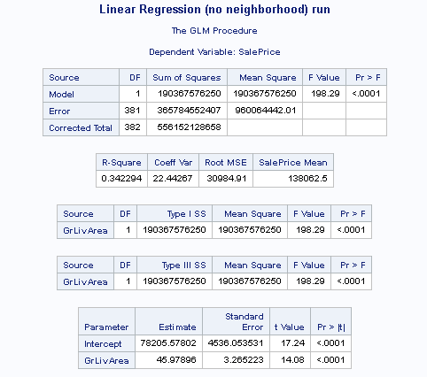

Influence of outliers appears to be minimal – we can check final model with/without them to assess affect on predictive capability of model. In building a larger model – we may want to keep them – as the addition of new features may explain the deviation in the norm.

#### Linear Trend:

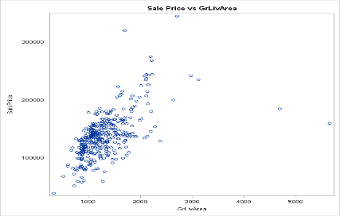

The mean sale price as a function of GrLivArea does appear to be relatively linear based on the scatter plot above (increasing GrLivArea tends to have a positive effect on the mean sale price)

#### Equal SD:

Within the prediction band, the SD of prices appears relatively constant (few signs of heteroscedasticity)

#### Independence:

No variables are assumed to be interdependent in this example.

**Model assumptions for basic linear regression seem to be well met. We will proceed with the analysis as is (inference on means)**

#### Simple Linear Model Results:

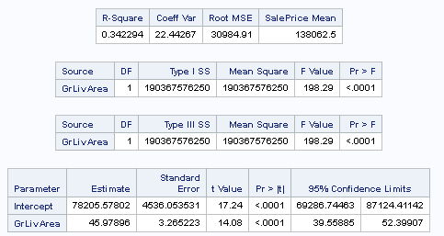

Assuming the only variable that contributes to SalePrice to be GrLivArea – there appears to be strong evidence of a non-zero intercept (0 = {69,286 – 87,124}). In this instance the intercept can be thought of as the cost of the land (i.e a house with no square footage).

A strong direct relationship between GrLivArea and SalePrice also exists, accounting for an effect of 45.9$/sqft of living space – or to state it more clearly – an increase of approx 4,600$ in sale price can be expected from every increase of 100sqft of living space. A 95% CL puts this accretive affect at anywhere from 3,900/100sqft to 5,200/100sqft.

Given the low R-square value for this regression (0.34) it is clear that there are other variables which contribute to SalePrice. GrLivArea only accounts for about 34% of the variance in SalePrice.

#### QOI 2: Does relationship between square footage (GrLivArea) and sale price (SalePrice) vary based on neighborhood?

To address this we will consider a regression of the form (including interaction terms)

SalePrice = 0 + 1 GrLivArea + 2 BrkSide + 3 Edwards + 4 GrLivArea|Edwards + 5 GrLivArea|BrkSide

*reference level for categorical variable is NAmes

#### Revisiting Assumptions:

#### Normality

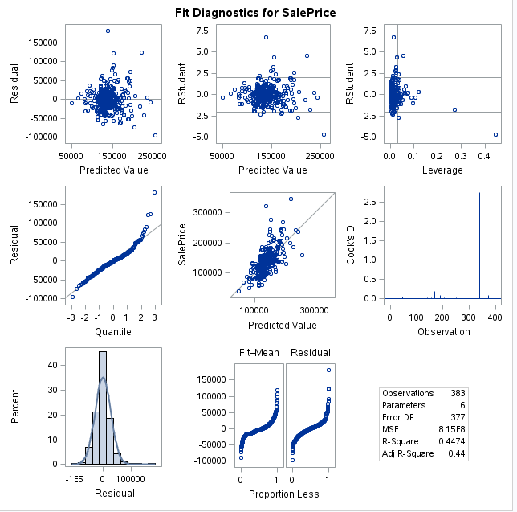

Final model may want to consider removal of high leverage observations – but data is otherwise clean. Potential curvature may indicate a future use of power features.

#### BrkSide/Edwards/NAmes

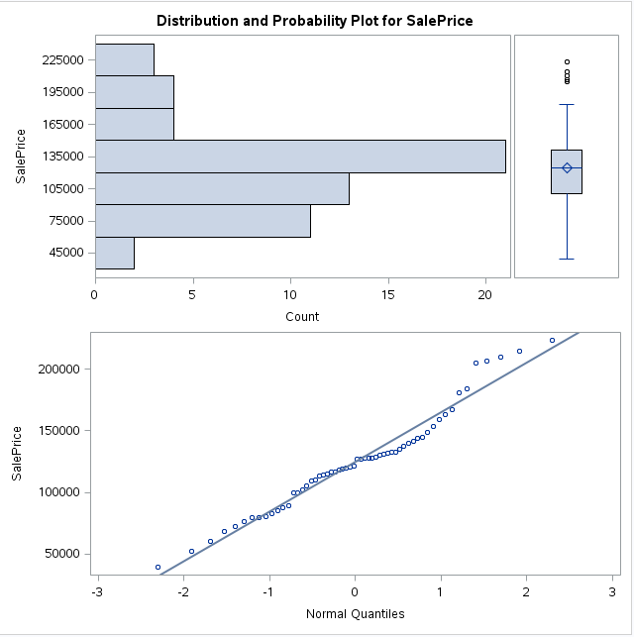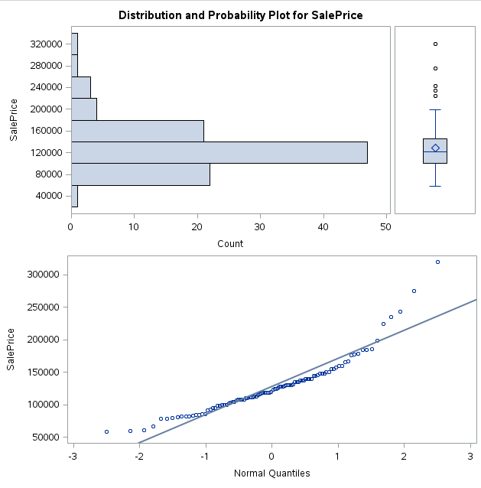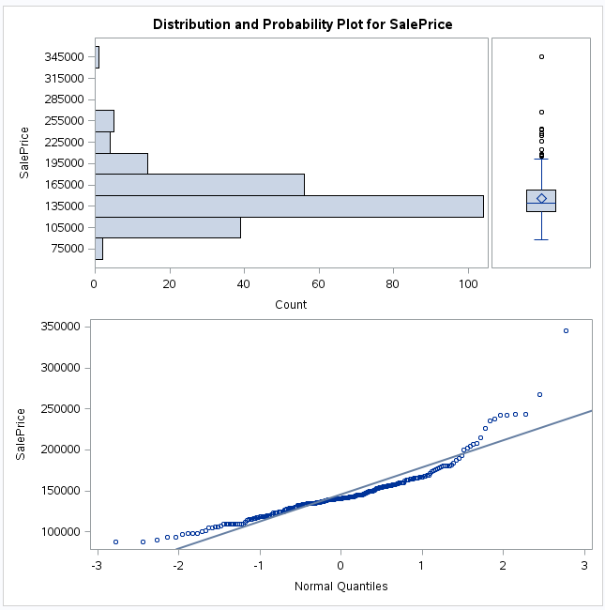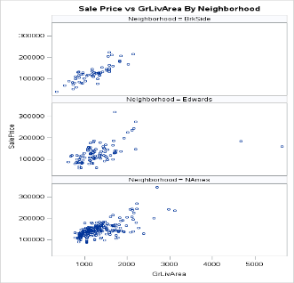

BrkSide shows strong evidence of positive skew though not enough to violate the assumption of normality.

Edwards also shows strong evidence of positive skew though not enough to violate the assumption of normality.

Of the three neighborhoods, Names exhibits the most positive skew though not enough to violate the assumption of normality.

#### Linear Trend

Generally speaking – each of the neighborhoods exhibits a linear relationship between GrLivArea and SalePrice. Edwards being somewhat suspect in that regard having observations with very high square footages and very low sale prices. Possible outliers , observations 524 and 1299 were both partial sales – this could be useful info down the road.

#### Equal SD

Scatter plots do not show any sign of heteroscedasticity amongst the 3 neighborhoods.

#### Independence

Since being in one neighborhood implicitly excludes a home from being in the others – we should be fine to assume independence.

#### Linear Model With Neighborhood Results

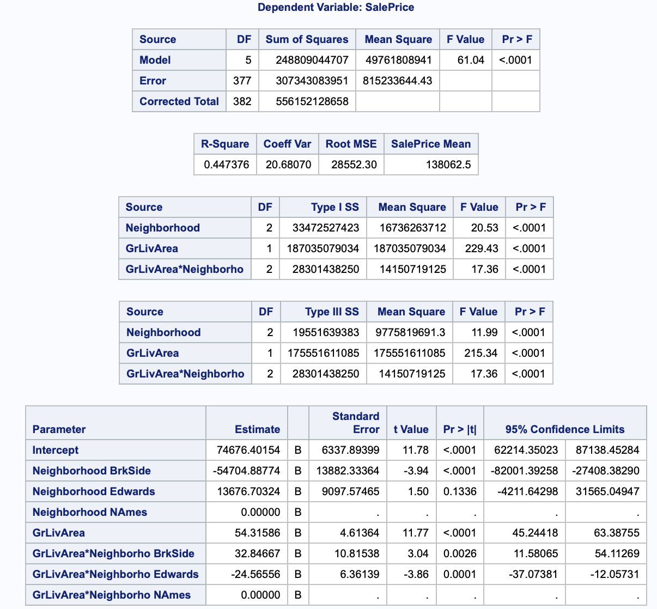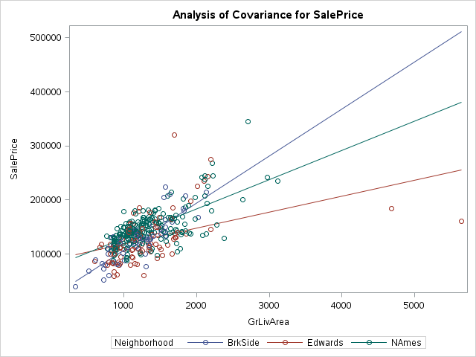

#### Interpretation:

All terms show statistical significance – despite the p-value for 2 being greater than our significance level (alpha = 0.01), we will include it in the model since the interaction term with GrLivArea is significant.

#### NAmes:

At the reference level we assume all i = 0 for i >1 which reduces the regression equation to the standard linear model with an expected mean of approximately 74k [62k, 87k] with an expected increase in value of approximately 5,413$ [4,520 – 6,338] per 100sqft of GrLivArea

SalePrice = 0 + 1 GrLivArea : (SalePrice = 74,676+54.31*GrLivArea)

#### BrkSide:

At the next level we assume all i = 0 for i = 3,5 which reduces the regression equation as follows:

SalePrice = 0 + 1 GrLivArea + 2 BrkSide + 4 GrLivArea|BrkSide : (SalePrice = 19,972+87.16*GrLivArea)

An expected mean sale price of approximately 20k with an expected increase in value of approximately 8,716$ per 100sqft of GrLivArea

#### Edwards:

At the next level we assume all i = 0 for i =3 which reduces the regression equation as follows:

SalePrice = 0 + 1 GrLivArea + 3 Edwards + 5 GrLivArea|Edwards : (SalePrice = 88,353 + 28.75*GrLivArea)

An expected mean sale price of approximately 88,353k with an expected increase in value of approximately2,875$ per 100sqft of GrLivArea

Kaggle Comp